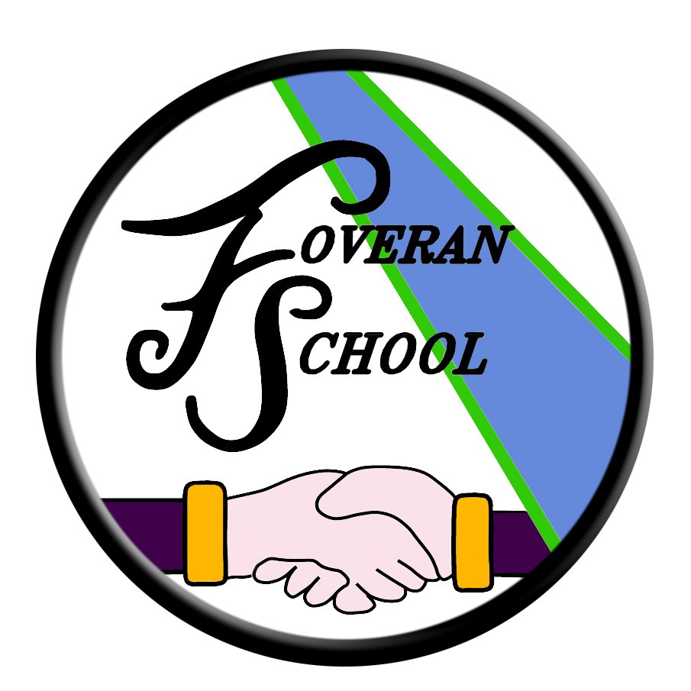

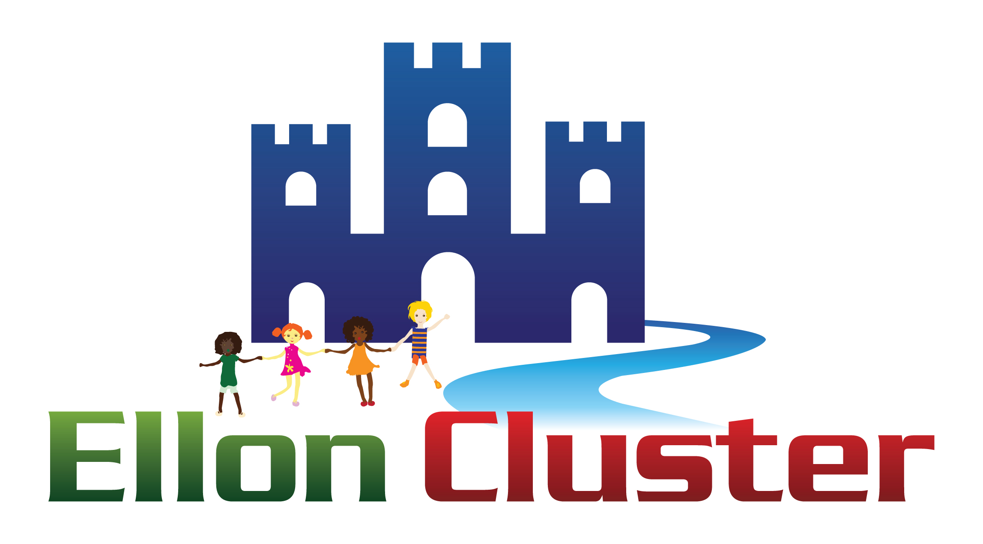
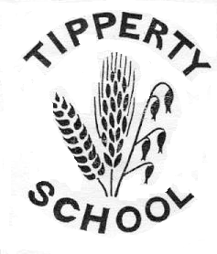

ELLON ACADEMY & CLUSTER

LEARNING AND TEACHING POLICY

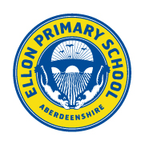
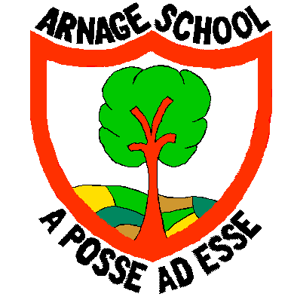
February 2016
A
PS

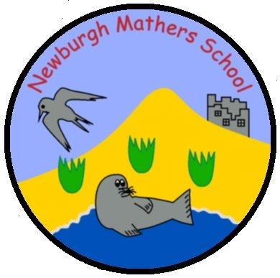

CONTENTS

Section Page

1. BACKGROUND AND RATIONALE 3

2. CLUSTER AIMS 6

3. LEARNING AND TEACHING POLICY AIMS 7

- Curricular Areas 7

- Approaches to Learning 9

c) Learning across the Curriculum 12

4. ELLON ACADEMY AIMS 14

5. POLICY CONSULTATION PROCESS 16

6. IMPLEMENTATION STRATEGIES 17

7. STAFF DEVELOPMENT AND RESOURCES 17

8. POLICY EVALUATION AND REVIEW 17

- REFERENCES 18

- Background and Rationale

This Learning and Teaching Policy document is intended to be considered in conjunction with the Curriculum Framework 3-18 for Aberdeenshire which in itself provides clear guidance on the core principles for effective learning, teaching and assessment. This document gives schools a structure to develop the four capacities based on the experiences and outcomes within the Curriculum for Excellence (CfE). The Curriculum Framework 3-18 for Aberdeenshire also sets out entitlements which schools and learning communities have a responsibility to provide for every child and young person in Aberdeenshire.

The Aberdeenshire Curriculum Framework is itself based on the principles of Building the Curriculum 3, which highlights that the curriculum is the totality of all that is planned for children and young people throughout their education, encompassing:

- Ethos and life of the school as a community
- Curriculum areas and subjects
- Interdisciplinary learning
- Opportunities for personal achievement.
- Education for learning, life and work

The Ellon Cluster Learning and Teaching Policy must also be considered in light of both Building the Curriculum 4 and 5 and the advice and direction on skills development and on assessment given in these documents. More recently, the Policy has been revisited in the light of HGIOS 4.

Historic Perspective

Ellon Cluster has always had high quality learning and teaching experiences at the heart of all policy.

Within Ellon Academy, the Learning and Teaching Committee operated at the school for many years and traditionally boasted active representation from across all areas of the school, both teaching and non-teaching, promoted and non-promoted staff. The committee was proactive in establishing and promoting AiFL priorities across the school, as a means of embedding meaningful assessment across learning. Sharing Learning Intentions and Success Criteria, Self and Peer Marking and Asking Better Questions became the whole-school focus areas during this period and this drive was recognised in the positive HMIe Inspection published in February 2008.

Ellon Cluster Primaries have been implementing AiFL Strategies since 2004 through joint In-service days and twilight sessions with a positive impact on Learning and Teaching. The approaches to assessment developed through Assessment is AiFL provide a sound platform to support this planning. Each primary school in the Cluster ensured that learning, teaching and assessment should be designed in ways that reflect how different learners progress to motivate and encourage their learning.

In August 2009, in the light of the national Curriculum for Excellence initiative, the Ellon Academy Learning and Teaching Committee was reformed as the Learning for Excellence Group, again with representation from all Faculties across the school, non-teaching staff but importantly, for the first time, cluster primary colleagues. During session 2009-2010, the Group, in conjunction with the Cluster Transition Group, Ellon Academy SLT, senior pupils and the school’s Management Group, supported all staff in preparation for delivery of CfE from August 2010. Significantly also, during session 2009-2010, curricular working groups comprising P6/7 and secondary staff, were established for each of the eight curricular areas as a means of planning effective (curricular) working across primary and secondary. During session 2010-2011, the working groups were expanded to include all cluster P4 – P7 and all secondary teaching staff. At the heart of planning was effective Cluster coordination of teaching and learning, the continuing embedding of AiFL practices, a joint approach to delivery of the Level 2 and Level 3 national Experiences and Outcomes, a shared approach to assessment and a coherent delivery of Aberdeenshire’s “A Curriculum Framework 3 – 18”, specifically the Entitlements highlighted in that document.

Where we are now?

From session 2011-2012 to 2013-2014, as Ellon Academy, in line with all secondary schools, moved towards the Senior Phase of Curriculum for Excellence and moved towards the qualification stage of the revised curriculum, it became necessary to reconsider focus areas for primary / secondary cluster liaison. Cluster twilights moved to 2 per session with a focus on Sharing Standards, across learning. In December 2013, the cluster hosted a successful showcasing of joint working across all faculty areas. In May 2014 a World Café was held at Ellon Academy to allow primary/secondary practitioners to see the materials that had been jointly produced across the cluster. During the current session the time commitment has remained at two cluster meetings each session and this pattern will continue, with each meeting having a particular focus area, ensuring all eight are visited over a period of time. This session the focus has been on Mathematics / Numeracy with Ellon Academy staff / SfL staff working with cluster primaries to ensure effective delivery of Numeracy across the cluster.

Ellon Academy currently has in place 3 Leaders of Learning, Literacy, Numeracy and Health and Wellbeing. All three leaders have carried out detailed audits of the curriculum / ensured coverage of Experiences and Outcomes across curricular areas and worked with both faculties and primary colleagues to ensure effective delivery / development of all three cross cutting themes. Early stage planning is already in place for an Inset Day, in November, bringing together staff across the cluster to work on the above three focus areas.

Ellon Academy has also recently appointed a PT Achievement, tasked with working with staff across the school to ensure the effective delivery and Quality Assurance of our of key Achievement agenda. Key focus areas include:

- Planning and coordinating the delivery of the NPA in Enterprise and Employability (N5) and / or Enterprise and Business (N6) to Senior Phase pupils
- Mentor S1-S6 pupils as appropriate, identified through SIMD data, to ensure progress in learning and overall attainment is maximised
- Progress the UNRRS agenda
- Liaise with PTGs / DHT pupil support to identify SIMD 1-5 pupils / LAC pupils and ensure these pupils are meeting appropriate levels of achievement
- Coordinate BGE Experiences and Outcomes to ensure all incorporated in to S3 Profile / collated into Princes Trust XL programme / collated to maximise the 2 year WAP programme.
- Continue to implement the S3 into S4 Work Experience programme

Ellon Cluster Schools endorse the aspiration, set out in the suite of “Curriculum for Excellence” documentation, that all children and young people should be successful learners, confident individuals, responsible citizens and effective contributors to society.

The ability to learn is fundamental in our ever changing world of education, work and leisure. Ellon Cluster is committed to developing successful learners and providing the highest possible quality of teaching and learning experiences. We recognise that learning takes place in a range of contexts, namely in the home, workplace and wider community, utilising a vast range of resources and media and including online resources. The Ellon Cluster actively seeks to support and facilitate excellence in learning and teaching through quality partnerships which involve learners, teachers, parents, employers, volunteers, other education providers and the wider community. We recognise the importance of taking account of learners’ prior learning and current progress. Assessment is integral to the learning process and includes feedback on the ongoing and overall progress made by learners. Reflection on both cluster practice and understanding, applying and sharing standards in assessment is central to ongoing improvements in learning and teaching and raising achievement across the Cluster.

Ultimately, Ellon Cluster is committed to collaborative working practices and we feel this is essential in promoting successful learning. The creation of a positive learning climate and ethos across the cluster strengthens a joint working approach, essential if high quality learning and teaching is to take place.

Rights Respecting School

The Ellon Academy Learning and Teaching policy is underpinned by the United Nations Rights Respecting Schools agenda, a Unicef UK programme that aims to place children’s rights at the heart of schools. The aim of RRSA is to embed children’s rights into schools’ ethos and culture to improve well-being and develop “every child’s personality, talents and abilities to the full” (Article 29 CRC). develop every child’s talents and abilities to their full potential. Currently, the school is bidding to achieve a Level 2 Rights Respecting Schools’ Award. Ellon Academy currently sits at level 1, with the aim of becoming level 2 accredited by summer 2016. The Award recognises a school's achievement in putting the United Nations Convention on the Rights of the Child (CRC or UNCRC) into practice within the school and beyond. The 4 standards for the RRSA are:

- Standard A: Rights-respecting values underpin leadership and management
- Standard B: The whole school community learns about the Convention
- Standard C: The school has a rights-respecting ethos
- Standard D: Children are empowered to become active citizens and learners.
- CLUSTER AIMS

- Achievement and Attainment

We have the highest expectations for every single young person who enters Ellon Cluster. All our young people are given every encouragement to aim for the highest possible levels of achievement in educational attainment and life skills.

- Framework for Learning

We aim to provide quality learning and teaching experiences for all our pupils, based on their unique aptitudes, needs and abilities, delivered by professional and highly dedicated staff. By constantly reviewing and evaluating the curriculum, we aim to ensure that the needs of all learners are addressed. We see every individual as unique and make every effort to make each learner aware of each school’s responsibilities to them and also their responsibilities to the school, fellow pupils and the local community. Also, we have very high expectations for the learning that takes place in every classroom across the cluster, and for each pupil’s contribution to this. Good classroom relationships are crucial to developing a positive school and cluster ethos, firmly built on positive relationships between all partners.

- Inclusion and Equality

Ellon Cluster is committed to the philosophy of inclusion. We aim to help every individual pupil to benefit from education, and take pride in the support we continue to provide for pupils of all abilities and needs, within a framework of equal opportunities. We aim to be a caring community, providing the highest possible levels of support for all pupils. All members of the Ellon Cluster Community are valued and respected.

- Values and Citizenship

Promoting education across the Ellon Cluster is firmly founded on a partnership that aims to teach pupils respect for themselves and others. This partnership working also aims to make pupils aware of their rights and responsibilities both within the cluster and school communities and as part of society generally, thus developing effective skills of citizenship and an awareness of the need to care for and value our environment.

- Learning for Life

Ellon Cluster aims to create a learning environment that enables pupils to develop creativity, ambition, enterprise, and the skills and attitudes required for success in life in the 21st Century.
- LEARNING AND TEACHING POLICY AIMS

- Curriculum Areas

All staff in the Ellon Cluster have a responsibility to develop, reinforce and extend learning in the following areas:

- Health and Wellbeing across learning
- Literacy across learning
- Numeracy across learning

It is recognised that the CfE Curriculum Areas need not be curriculum organisers. However the Ellon Cluster decided to use these to organise learning. In so doing, contributors to the learning process ensure learning takes place in an organised and consistent way across a broad range of contexts.

The CfE Experiences and Outcomes describe the expectations for learning. Taken together, they sum up national aspirations for every young person: the knowledge and understanding, skills, capabilities and attributes we hope they will develop. In the Ellon Cluster, staff provide stimulating learning environments for the children to enhance these areas.

The CfE Building the Curriculum documentation (1) focuses on the Curriculum Areas, each of which makes its own unique contribution to developing the four capacities. Each does so, both within its own disciplinary contexts and through connections with other areas of learning.

The 8 Curriculum Areas are:

Expressive Arts
The inspiration and power of the arts play a vital role in enabling our children and young people to enhance their creative talent and develop their artistic skills through Art and Design, Drama, Music and Music Technology.

Health and Wellbeing
Learning in Health and Wellbeing ensures that children and young people develop the knowledge, understanding and skills which they need now and in the future.

Languages
English and Literacy - Literacy is fundamental to all areas of learning, as it unlocks access to the wider curriculum and increases opportunities for the individual in all aspects of life.

Modern Languages - Learning other languages enables children and young people to make connections with different people and their cultures.

Across the Ellon Cluster, these areas currently meet as two separate groups.

Mathematics
Mathematics and Numeracy is important in our everyday life. It equips us with the skills we need to interpret and analyse information, simplify and solve problems, assess risk and make informed decisions.

Religious and Moral Education
Scotland is a diverse nation whose people hold a wide range of beliefs. Religious and Moral Education enables children and young people to explore the world’s major religions and to develop their own beliefs and values.

Social Studies
Through Social Studies, children and young people develop their understanding of the world by learning about other people and their values. RME and Social Studies form one curricular area – Humanities – across the Ellon cluster.

Sciences
Learning in Science develops an interest in, and an understanding of, the living, material and physical world. Collaborative investigative tasks within science develop important skills, which allow young people to become creative, inventive and enterprising adults, in a world where the skills and knowledge of the sciences are needed across all sectors of the economy.

Technologies
Children and young people will develop their creativity and entrepreneurial skills and be encouraged to become innovative and critical designers of the future. Currently this curricular area incorporates both Business and Technical Education.

- Approaches to Learning

In the Ellon Cluster we acknowledge that children and young people learn in a variety of ways ensuring all learners benefit from a wide range of teaching approaches, contexts and learning environments. The main approaches to learning we employ are outlined below; these approaches are not mutually exclusive but overlap to enhance the learning experiences of pupils.

As outlined in the CfE Building the Curriculum 3 document (BtC3), learner entitlements are key to teaching and learning. “Every learner is entitled to personal support to enable them to gain as much as possible from the opportunities that CfE offers”. Approaches to learning across the Ellon Cluster will actively take account of:

- Challenge and Enjoyment
- Breadth
- Progression
- Depth
- Personalisation and Choice
- Coherence
- Relevance.

Progressive high quality learning and teaching requires positive interactions between all stakeholders based on the 5 principles of formative assessment:

- Clarifying and sharing learning intentions and success criteria
- Engineering effective classroom discussion
- Quality questioning and learning tasks that elicit evidence of learning
- Providing feedback that moves the learner forward
- Activating learners as owners of their own learning and activating learners as instructional resources for one another.

Learners are supported in identifying and reflecting upon their learning enabling them to set realistic learning goals. Learners are grouped in appropriate and flexible groupings based, as appropriate, on; interest, experience, attainment, stage and purpose. Across the Ellon Cluster, approaches to Learning and Teaching incorporate both the thinking and rationale of Aberdeenshire’s “Improving Learning” documentation and approaches to Learning and Teaching highlighted on the Education Scotland website.

Homework is a key aspect of learning across the Ellon cluster. Ellon Academy’s Homework Policy is currently being revisited with an updated policy document due by the end of session 2015/2016.

The Ellon Cluster is committed to progressing the following key areas to ensure high quality teaching and learning is maintained.

- Active Learning

Active learning, engages and challenges learners’ thinking using real life and imaginary situations, is promoted across all areas of the curriculum at all stages in the Ellon Cluster. Active Learning can support learners' development of the four capacities in many ways. Specifically:

- Successful learners through using their imagination and creativity, tackling new experiences and learning from them, and developing important skills including literacy and numeracy through exploring and investigating while following their own interests

- Confident individuals through succeeding in their activities, having the satisfaction of a task accomplished, learning about bouncing back from setbacks, and dealing safely with risk

- Responsible citizens through encountering different ways of seeing the world, learning to share and give and take, learning to respect themselves and others, and taking part in making decisions

- Effective contributors through interacting together in leading or supporting roles, tackling problems, extending communication skills, taking part in sustained talking and thinking, and respecting the opinions of others.

Ellon Academy is committed to a number of curricular initiatives all of which allow opportunities for the above capacities to be effectively developed, namely:

- S1/2 Enrichment Programme
- S1/2 Enterprise Course
- S2 IDL Programme
- WAP
- S5 Wider Achievement Programme.
- S3,5,6 whole year group Enterprise and Entrepreneurship days
- Inclusive whole school sports day
- Whole school theme weeks and days like: Fair Trade, Environment, UNRRS etc
- S5,6 electives and work placement learning options

- ICT Competence

In a highly technological world, the development of effective ICT skills is vital for the Ellon Cluster. ICT should be recognised as a responsibility of all and is key to developing the skills for learning, life and work needed in the modern world. The learning and teaching opportunities provided in the Ellon Cluster must reflect this need. Approaches include, but are not limited to:

- GLOW
- Games Based learning
- Show My Homework
- Use of Microsoft office for a variety of different classwork activities.

- Creative Thinking

Using our imagination and our knowledge, we learn to explore new possibilities rather than established norms. Embedding opportunities to be more creative in our learning allows us to look at things in a new lights and examine problems with an open mind. By promoting creativity, it not only improves self-esteem, motivation and achievement of learners, it also engages them in their learning. By encouraging learners to take ownership of their learning, it helps develop problem solving skills. Promoting creative learning opens up opportunities to work with others, leading to effective contributors and successful learners.

Pupils who are encouraged to think creatively:

- Become more interested in discovering things for themselves
- Are more open to new ideas and challenges
- Are more able to solve problems
- Can work well with others
- Become more effective learners
- Have greater ownership over their learning.

- Focus on Outdoor Learning

Outdoor Learning has many advantages including the opportunity to explore and discover, and significantly allow for planned and managed “risk taking” to take place. Mentally, physically and emotionally the outdoors is a very different place from the classroom. In the Ellon Cluster planned opportunities for outdoor learning takes place in a number of different contexts including; using the school grounds for both the formal curriculum eg taking Maths outdoors and the more vocational or extra - curricular learning such as developing a school garden or using the local environment eg a Victorian walk around Ellon or a ranger guided visit to Forvie Sands Nature Reserve. Within Aberdeenshire this may involve visits to one of the many historical, cultural or environmental centres (eg, Fyvie Castle). It may also involve learners in residential trips both within and beyond Aberdeenshire

- Cooperative and Collaborative Learning

Cooperative and collaborative learning promotes the idea that young people’s learning is best served when they have opportunities to learn with and from each other, and are shown how to do so effectively. We no longer consider that a ‘good’ classroom is necessarily a quiet one; we understand that learning is frequently most effective when learners have the opportunity to think and talk together, to discuss ideas, question, analyse and solve problems, without the constant mediation of the teacher. This particular area of teaching and learning was a focus area for an Ellon Cluster Inset Day on 16 November 2010 with all Ellon Cluster staff invited to attend a series of workshops on Cooperative Learning. Formal evaluations of the day highlighted both the validity of it and the need to ensure the practice and methodology highlighted and exemplified, be progressed across the Cluster in a coherent way.

- Learning across the Curriculum

Learning across the curriculum is the responsibility of all in the context of Health and Wellbeing, Literacy and Numeracy. This coupled with the specific themes of Learning for Sustainability, Global Citizenship, Enterprise in Education and Financial Education will give our children and young people opportunities to learn about their world and how to be active participants in it through well-planned curricular contexts which underpin the design of the cross sector curriculum in the Ellon Cluster.

The schools across the Ellon Cluster will work together to achieve cross-sector collaboration on contexts and themes whilst building the capacity of individual teachers to deliver the innovative disciplinary and interdisciplinary experiences.

Depth and application will be achieved through careful planning at centre-level to design a coherent curriculum which takes account of the ethos and life of the school as part of the wider community, stages of transition, partnership–working, personalisation and choice. Both the Cluster Support for Learning Team and cluster transition staff will have important roles to play here.

In order for our learners to have wide opportunities,

Centres will provide opportunities for staff to:

- Keep abreast of local and national priorities, policies and legislation (3,10)

- Develop capacity through in-house and further CPD opportunities, with a particular focus on peer observation

- Progress further in building relations with the other sector as a means towards building their own capacity

- Ensure resources are available where and when appropriate to carry out expectations as set out in BtC 3-5 (3,10)

- Create opportunities to experience outdoor learning in the immediate environment (3)

- Build leadership capacity

- Create opportunities to experience outdoor learning in the immediate environment

- Foster the development of core skills for learning, life and work and outlined in BTC 5, the Developing Young Workforce requirements and HGIOS4.(3, 12)

Teachers will:

- Take responsibility for areas out with their subject expertise in order to deliver cross-curricular / interdisciplinary contexts (3)

- Contribute to centre and local curricular developments

- Through selection of interdisciplinary themes, allow children and young people opportunities for personalisation, choice and personal target setting and will provide appropriate feedback with opportunities for improvement (1,2,3,4,5,6,7,9,11)

- Draw on expertise available in the community to fulfil certain experiences (4)

- Focus on specific outcomes as part of the designed, coherent curriculum (1,2,3,8.11)

- Use technologies to advance the problem-solving capacities of the children in all areas of the curriculum (8,10)

- Seek advice from those who have the capacity as to the appropriate use of ICT in particular (5,7,10)

- Teach problem solving, critical thinking and risk-aware skills to children through contexts appropriate to their development. (1,4,5,9,12)

Pupils will:

- Know what they are learning and why (1,2,6,11)

- Be able to talk about their learning (1,2,4,9,11)

- Learn well together (1,4,11)

- Enjoy their learning (1,4,7,10)

- All be helped to make progress in their learning (2,5,6)

- Learn in classrooms, homes and beyond (1,4,8,10)

- Celebrate their learning.(1,7)

- ELLON ACADEMY AIMS

Partnership Working

Partnership working is essential for effective learning and teaching and for effective support for pupils. Partnership working has many strands permeating all aspects of the work of the cluster / school. Partnership work involves all staff and pupils within Ellon Academy.

- Guidance / PSE at Ellon Academy

Partnership working has a crucial role in achieving all the H and WB experiences and outcomes which allow Es and Os to be organised and planned for. A collaborative approach ensures progression within and across levels, particularly at transition and enhances learning through regular professional dialogue across partnerships, sharing knowledge, information ideas and expertise.

- Targeted Links for Individuals

It is important to work in partnership to “get it right for every child”. All Cluster staff can work with a range of link partners such as Educational Psychologist, CLD, Social Work, Young Persons Department, LEAD, Compass, Barnardos, CAMHS, Sensory Impairment Service, BEat

- Universal Links for All Young People

Building strong partnerships with both local and national employers helps to develop enterprising, entrepreneurial and employability skills and attitudes in young people. It provides experience of the world of work and enables pupils to place their school work in a real-world context. Ellon Academy has a range of partnerships, these include:

- Careers Links (STEM, BP, WFT, Aberdeenshire Council. Mock Interviews, Careers Evening, CITB, ECITB etc.

- Health and Wellbeing Links (Teenage Cancer Trust, Safe Drive Stay Alive, Police, Organ Donation, Penumbra, Heart Start, Teen Drive CLD etc.

- Whole School Learning for Sustainability Partnership Links

The Ellon Academy Global Citizenship and Wider Achievement Committee has whole school representation in order to manage global citizenship, learning for sustainability and wider achievement across learning. Examples of global citizenship in Ellon Academy include, but are not limited to, Fairtrade work, promoting the UNRRS, World Challenge, Eco School, Driving Ambition programme with Police Scotland, undertaking voluntary work in in local communities and school.

- Enterprise and Entrepreneurship Partnership Links

The Enterprise and Industry Committee ensure that enterprise, entrepreneurship and employability opportunities are embedded in all courses within Ellon Academy to prepare pupils for work and life. Incorporating the aims and ideals of “Developing Scotland’s Young Workforce”, Ellon Academy has a vast range of business and employer links who provide speakers to work with Faculties. Examples of our enterprise and entrepreneurship partnership links include Enterprise themed inductions days for S1/3/4/6, ongoing work with the Wood Family Trust, ongoing work as an “Enhanced BP School” and enhanced STEM school.

- Continuing Professional Development and Partner Links

Partner links provide Cluster schools with a wide range of CPD opportunities free of charge via inclusive practice twilight or lunchtime sessions. These can include specialist staff from NHS Grampian, Social Work, Community learning and Development, Council services, Charity organisations etc or experienced cluster staff. Additionally CPD opportunities can be purchased via partnerships links eg national training provided by the SQA.

- Wider Achievement and Partner Links

Within Ellon Academy the PT Achievement, leaders of learning and an extensive range of whole school committees and working groups manage and lead wider achievement programmes. A wide range of partnership links allow the wider achievement programmes to operate, including WAP week (involving a range of partners supporting staff to deliver alternative activities, camps, trips, etc) and the curriculum (partner links are used to support the delivery of Enrichment programmes / Wider Achievement timetables period across the curriculum).

- Transition

The Primary / Secondary Transition Process

The move from primary to secondary schools for most pupils is a very easy one but it can be an anxious time for some pupils and their parents / carers. To ease this, we work closely with our class teachers, support staff, pupils and parents / carers to minimise concerns. During the transition process, detailed information is gathered on each pupil and shared with staff across the Academy to ensure effective personal and learning support strategies are in place.

To facilitate individual needs, an extended transition programme and bridging groups are available for pupils with significant additional support needs. Health professionals, Educational Psychologists, Social Work, CSM Pupil and Family Support workers, Community Learning workers, other professionals and voluntary organisations may be involved in ensuring smooth transition from primary schools to the Academy.

Support with transition also exists at the following key stages:

- S2 into S3 Transition / Personalisation and Choice with the BGE

- S3 into S4 “Subject Refresh” / Transition into the Senior Phase

- Transition into Post School Education and the World of Work

- POLICY CONSULTATION PROCESS

Ellon Cluster welcomes a wide response from all stakeholders. The following will be engaged in the consultation on our learning and teaching policy:

- Cluster Transition Group

- Short Life Learning and Teaching Working Group

- Ellon Cluster Schools Group (Cluster HTs)

- Ellon Academy SLT

- Primary Senior Leadership Teams

- Ellon Cluster Learning for Excellence Group

- Ellon Academy Pupil Senate and other Pupil Voice Groups

- Primary Pupil Councils

- Cluster Parent Councils

- Ellon Academy Website and Social Media Sites

- Ellon Cluster QIO.

This document is intended to be an ongoing working document and guide. We will continue to consult widely with as many individuals and organisations as possible in order to ensure we represent the real views of our staff, pupils and parents in order to ensure the highest possible teaching and learning experiences across the school. This policy will be regularly reviewed and up dated.

- IMPLEMENTATION STRATEGIES

- Implement changes following consultation process subsequent to completion of Learning and Teaching Policy.
- LfE Representatives / PHTs to coordinate familiarisation and implementation across the Cluster.
- Preliminary discussion at November / February Insets.
- Evaluation of Policy to be carried out on a three yearly basis.

- STAFF DEVELOPMENT AND RESOURCES

Ellon Cluster is committed to supporting the delivery of excellence across the Ellon Cluster. Staff will raise issues relating to training needs and resources through:

- School / Faculty improvement plans
- PDRS meetings
- Inset workshops as appropriate.

- POLICY EVALUATION AND REVIEW

In line with cluster policy, ongoing review of this document will form part of a five-year cycle. The processes outlined in the consultation section will also be used for the monitoring and evaluation of this policy.

It will be made clear to all using this policy that it is not a finished piece but a working document that should be added to, updated and improved as developments in teaching and learning are developed across the Ellon Cluster. If you have any suggestions for additions or improvements for this document, please email lindaduthie@aberdeenshire.gov.uk (Secondary) or jill.thomson@aberdeenshire.gov.uk (Primary). Your suggestions will then be forwarded to the Cluster’s LfE Group for consideration

- References

The following is a list of references which have contributed to the thinking behind this policy and may assist classroom teachers in approaches to learning and teaching.

Pedagogies

AiFL – The Learning Set
Hattie’s “Visible Learning”
Bloom’s Taxonomy
Cognitive Behaviour Approach
Collaborative Learning
De Bono’s Thinking Hats
Emotional Intelligence
Learner Responsibility
Learning Styles
Multiple Intelligences
Social Constructivism
ZPD (Zone of Proximal Development) Lev Vgotsky

Texts / Papers

From Thinking Skills to Thinking Classrooms Carol McGinness, 1999
The Wood Report

Websites

www.aberdeenshire.gov.uk
Building the Curriculum 3 – 18: A Curriculum Framework
www.educationscotland.org.uk
Building the Curriculum 1 – 5
GTCS Website

